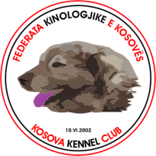FEDERATA KINOLOGJIKE E KOSOVËS - KOSOVA KENNEL CLUB
Rrokaqielli, 30000, Pejë ( Kosovë)
___________________________________________________________________________
(Official standard as of 12.10.2016)
DELTARI ILIR

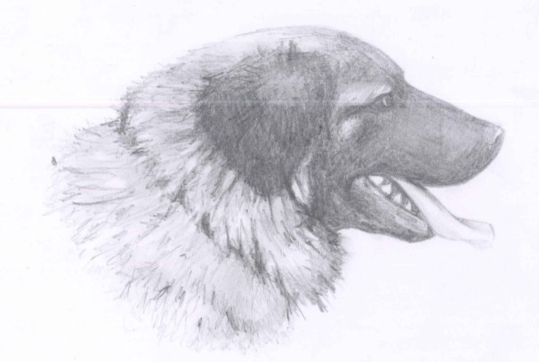

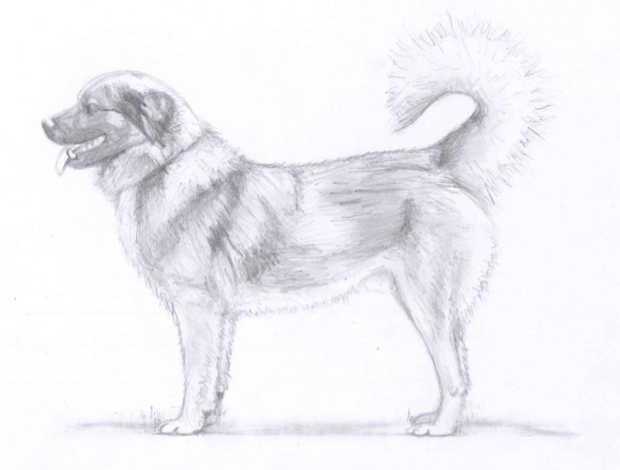

Origin: Kosova
Date of publication of the official valid standard: 12.10.2016
Utilization:, It is used for the protection of the flock, possesses guardian instincts.
Fci- classification: Group 2. Pinscher, Schnauzer, Molossoid breeds and Swiss Mountain Dog
Section: 2.2- Molossoid breeds, Mountain type
Without working trial
Brief historical summary: Herding dogs that dated back from the Bronze Age, in the ruling of Pelazgian Empire, and in the ancient times of the Iron Age, where a great treasure in the Illyrian Coast.
The dogs at that time where named after Illyrian tribes, or they where called shepherd dogs or Mountain Dogs. These facts are mentioned in the writings of ancient books.
In the Middle Ages during V-XIV centuries, Illyrians where interested in finding quality dogs that could serve for herding the sheep.
In Kanuni i Leke Dukagjinit, those dogs are mentioned.
After the XIV century and up until the XX century, we read about these dogs in the writings of The Ottoman Empire.
The breeding of Deltari Ilir continued until the 80-es of the XX century, where the selective breeding started.
Nowadays, the breed population consists of numerous, purebred dogs selected during a series of generation dispersed throughout Kosovo, Albania, Macedonia, Montenegro and Croatia.

General appearance and character:
The length of body comprises with 6-10% with height at the withers.
The head makes 4/10 of the dogs length.
The depth of the chest is 1/2 of the height at the withers.
The chest is slightly longer then deep for 5-8%.
The length of the skull correlates with the length of the muzzle as 3:2.

Brave, intelligent with an aristocratic behavior, which is not to be taken as an arrogance but rather as confidence. The dog is tolerant of the weak, but never for the dominant types. The Illyrian Shepherd shows a loyal devotion to one person, brave when it comes to protecting people and herds from wild animals.
Head: The head is medium in size and weight. It makes 40% of the dogs length, molossoid-lupoid type of head. Powerful, with non wrinkled skin. The length of the skull correlates with the length of the muzzle as 3:2.
The upper profile of the skull and muzzle are slightly divergent.
Cranial region:
Skull: The skull makes 60% of the length of the head. width and depth almost equal to the length of the skull.
Viewed from profile the skull is convex, slightly round.
Super ciliary arches, frontal furrow and occiput slightly accentuated.
Stop: Slightly pronounced, it forms an angle of 135° -145° between the skull and the frontal furrow.
Facial region:
Nose: Well developed, pigmented, the nostrils are well developed, parallel. The width of the nose is greater then the length of the nose. In dark colored dogs the pigmentation is black, while in other colors the pigmentation changes according to the coat color. Pigmentation in harmony with the color of the coat.
Muzzle: Slightly shorter then the skull, makes 40% of the length of the head. The bridge of the nose is perfectly straight, the length is slightly bigger then the depth as 9:10, while the width is by 25% smaller then the length.
Lips: Lips are of medium thickness and elasticity, tightly fitting.
The upper lip touches the lower lip in a closed angle.
Jaws/Teeth: Scissor bite and pincer bite.
Strong jaws, well developed teeth.
Cheeks: Slightly highlighted, the masticatory muscles are well developed and a little convex.
Eyes: Medium size, slightly almond in shape, dark brown color, the eyes give the dog an intelligent look, eyelids are tight fitting.
Ears: Triangular shape, the tip is round, medium size. The tip of the ear reaches the lower jaw, 1/2 of the length of the head, carried close to the cheeks, pendant. Covered with hair that are slightly longer then the hair of the muzzle and forehead.
Neck: The line of the neck or the crest forms an angle of 130° with the line of the back. The neck is 10% shorter then the head. The crest and the throat line are straight, muscular, covered with long hair.
Body: Well developed and muscular, the topline is horizontal from the withers to the croup, at which point it starts sloping down.
Withers: prominent, but the connection between the neck is unnoticeable. Moderately developed and broad.
Back: Strong, level, the withers and the spine makes 35% of the length of the dog.
Flank: Slightly convex, 20% of the height of the dog, the width of the flank is almost equal to the length of the flank.
Croup: Of medium length, they make 30% off the height of the dog. Sloping in a 30° angle. The imaginary horizontal line between the highest point of the pelvis and the lowest point of the pelvis, the height between them is 9-11cm.
Broad and muscular.
Chest: The chest makes 55% of the height of the dog, while the depth makes 50% of the dogs height, and the width makes 30% of the height. The perimeter of the chest should exceed the height at the withers by 25%.
Well ribbed up, deep in front, ribs slightly sprung.
Underline and belly: Well muscled, tucked up belly, the lower profile is gently rising.

Tail: The tail is placed 10% lower then the height at the withers, strong and thick at the root, tapering to the tip, covered with long fringe hair. The tail is carried in a sickle curve, when alert it is carried high, carried low when at rest.
Limbs:
- Point of elbow must be on an imaginary horizontal line with point of knee.
- The width between the two points of shoulders, makes up for 30% of the height at the withers. This is slightly wider than the width of the chest.
- The height from the elbows makes up to 52% of the height at the withers.
- The height from the shoulder point makes up to 75% of the height at the withers.
- The height from the ischium bone makes up to 85% of the height at the withers.
- The height from the hock joint makes up to 27% of the height at the withers.
Forequarters: Straight limbs seen from the front, vertically positioned, powerful and parallel.
Shoulder: Makes up of 30% of the height at the withers, or equal with the height of the neck. Diagonal, the shoulders forms a 50° angle, with the horizontal line. Slightly wider than half of the length of the shoulders, with powerful muscles. The angle of the shoulder is 105°.
Upper arm: Makes up of 32% of the height at the withers, with powerful muscles. The upper arm forms an angle of 55°, with the horizontal line. It’s position is more or less parallel with the median plane of the body.
¼ of the rear part of the upper arm is not close to the body.
Elbow: Close, but not touching. Parallel, the height at the elbow is slightly more than 50% of the height at the withers. The angle of the elbow is 140° -145°. The index of the thickness of the skeleton is 22.
Forearm: Well developed., powerful. Makes slightly less than 40% of the height at the withers, or slightly shorter than the length of the head. Parallel and well-fringed.
Carpal joint (Carpus): The wrist is in line with the forearm, straight, the pissiformis bone is clearly protruding.
Metacarpus (Pastern): The pastern makes up of 16% of the height at the withers. Seen in front and behind the pasterns are straight. Seen in profile they are slightly oblique, they make an angle of 22° with an imaginary vertical line.
Forefeet: They have the form of the spoon, well closed toes, covered with thick and short hair, well pigmented nails. Pads with dark pigment. Large feet: 11x9cm, 10x8cm.
Hindquarters: Seen in profile they are slightly vertical. Seen from the rear they are vertical and parallel.
Thigh: They make up to 36% of the height at the withers, 80% of the length of the thigh, powerful, muscular, the lower line is slightly convex, but the presence of the hair makes it hard to be seen. The angle between the thigh and the pelvis, in front is 90° -95°. The thighs, forms an angle of 60 ° with the imaginary horizontal line, seen from the rear.
Stifle(Knee): Round and large. The angle between the thigh and the lower thigh from behind is 115° -120°.
Lower thigh: The lower thigh is almost as long as the thigh. It makes an angle of 55° with the imaginary horizontal line. Strong bones, and muscles.
Hock joint: Well developed, thick and broad. The height measured from the ground makes up to 27% of the height at the withers. The angle between the pastern and the rear pastern, measured in front, is 145°.
Metatarsus (Rear pastern): Long and broad, cylindrical form, vertical and parallel, the rear part of the pastern is slightly forward. The dewclaws are sometimes present.
Hind feet: Slightly smaller and more narrow than the fore feet, oval shape, covered with longer hair than those of the fore feet, well pigmented nails,

Gait: Harmonic, with long steps, medium trot, (in length and as well height), while in long jumps it uses fast gallop.
Skin: Medium thickness, elastic and tight without wrinkles. Well pigmented, the color of the pigment corresponds with the color of the coat.
Coat: The head, forequarters and the front parts of the hindquarters have short hair. The ears have medium hair length, the neck, the upper parts of the body, the rear parts of the thighs have longer hair, the hair on the tail are long and fringed. The undercoat is thicker and shorter. The length of the hair is 6-13 cm, they are harsh to the touch, thick, strong and flat lying on the body.
Color: Deltari Ilir can have simple unicolor, complex unicolor, or brindle.
The colors can vary from white to dark grey. The primary color needs to cover 90% of the coat, while the other color, for example white, is located in the chest area, pastern, feet, muzzle and the tip of the tail(these are separated from the primary color). The coat can have nuances of complex colors ( darker color in the upper parts of the body, withers, around the shoulders and the head. The head can have lighter color in comparison with the body.

Weight and length:
Males are up to 67-75 cm
Weight: 45-55kg
Females are up to 62-70 cm in length
Weight: 35-45kg
The height should be in proportion with the weight, which gives the impression of a powerful but not a heavy dog.
1cm/700gr
Faults:
Any departure from the foregoing points should be considered a fault, and the seriousness with which the fault should be regarded should be in exact proportion to its degree and its effect upon the health and welfare of the dog and its ability to perform its traditional work.
Minor Faults:
- A head that is too lupoid.
- Absence of the first premolar.
- Tail carried in a sword like shape or tail rolled over the back.

Serious faults:
- Lighter or heavier weight.
- Prominent stop.
- Overbite or under bite without any space.
- Round and protruding eyes.
- Ears placed to high or to low on the head.
- The topline not a straight line (convex or concave).
- Feet turner neither in nor out.
- Slightly curly coat.
- The absence of the undercoat.
Disqualifying faults:
- Aggressive or overly shy dog.
- Any dog showing physical or behavioral abnormalities shall be
- disqualified.
- Significant deviation from required type and constitution( Lymphatic or gentle constitution)
- Large mastiff type of head.
- Converging head lines.
- Loose hanging skin of the throat line.
- Convex nose.
- Overbite and under bite with more than 1mm space.
- The absence of the incisors or the canines.
- Thick lips, hanging and vibrating.
- Small and round eyes.
- Hind legs in the form of the X and O shape.
- Tailless.
- Dogs with one testicle or none.
- Dimorphism.

N.B.
- Male animals should have two apparently normal testicles fully
descended into the scrotum.
- Only functionally and clinically healthy dogs, with breed typical
conformation, should be used for breeding.

